Tecumseh Trail Challenge Runners’ Guide
It’s almost race day for the 21st running of Tecumseh Trail Challenge!
Please review our web page for additional information, but here are some key points:
Check-in (Yellowwood Lake Youth Camp):
- Friday evening, 6-8 pm
- Saturday morning, 7-10 am
EVENT SITE MAP:
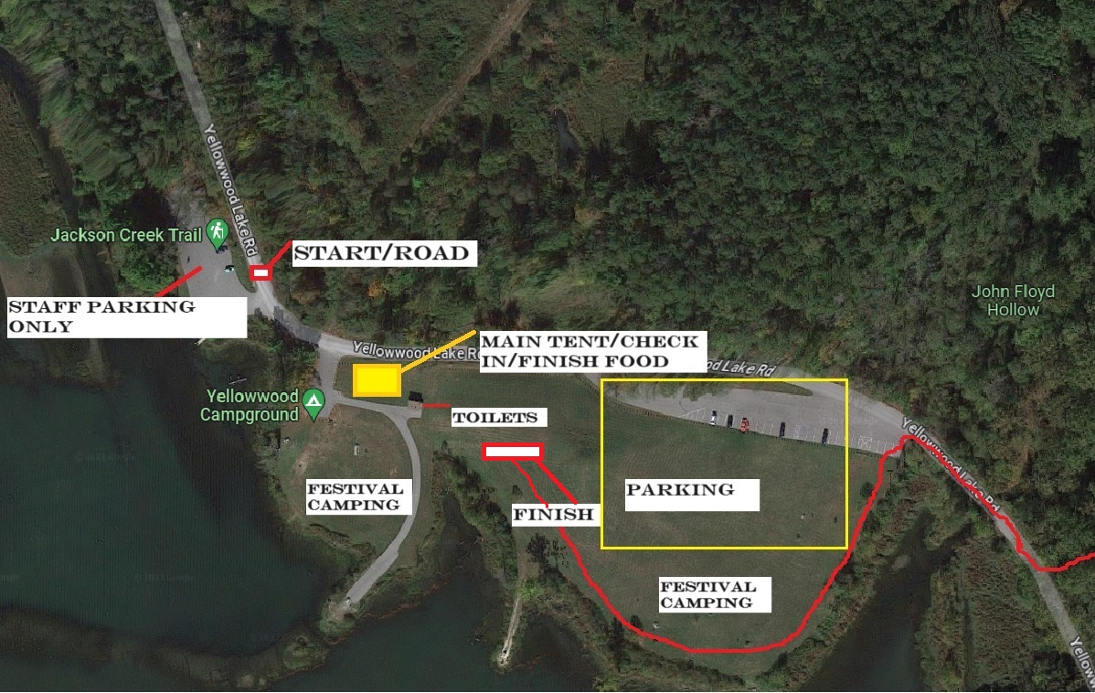

Race bib numbers are to be worn on the front of your body, visible at all times during the race.

Sweatshirts are a priority to those who purchased them with preregistration. The deadline was extended to Oct 12th. If you did not purchase a sweatshirt with registration, you may purchase one after your race while supplies last. Please bring cash, cell service is pretty awful at the site headquarters. If you do not attend the event, we are unable to mail sweatshirts. You MUST be present to pick it up.
Race Schedule
- 9 am (50k)
- 9:15 am (26.2)
- 9:30 am (13.1)
- 10:00 am (8 Mile fun run)
Cutoff: 6:30 pm (all distances)
PLEASE VISIT AND REVIEW WEBSITE FOR SPECIFIC CUT OFFS AT AID STATIONS AS WELL AS AID STATION MENU!
You must maintain an average pace that will allow you to finish by 6:30pm, or you will be removed from the racecourse. *PLEASE NOTE Distances are subject to 5% shorter or longer than advertised. Plan accordingly.
Parking: Parking will be available on the grass and the paved area at the race site. The “Jackson Creek Trail” parking area will be closed for staff and volunteer use. Parking will fill up fast! Additional parking is available at the forest office, and in any open campsite. A shuttle bus will transport runners to the start line, with stops at the office mailbox and the main campground loop.

The shuttle bus runs from 7 am to 9:45 am.
- A passenger van (look for DINO magnet on the door) will be available to shuttle finishers back to the vehicles once the race is over.
Spectator Locations: Suggested spectator locations are:
- Start/finish.
- walk north to (Cemetery AID Station / lap split location)
- (Yellowwood Dam AID Station – cars with low ground clearance not advised)
- Horse camp about 2 miles south of start /finish (course crosses Yellowwood Rd).
ABSOULUTELY NO SPECTATING ALLOWED at the northern end of the 50k/26.2 out and back section for safety.
Course Markings: It is your responsibility to understand the course! Maps and GPX files are available on the website for each distance.
Direct link for maps: 50K , 26.2 , 13.1 , 8Mile
The course will be heavily marked with pink ribbon and signage at key points and intersections. We still strongly recommend you study the course and download the GPX files.

AID STATIONS
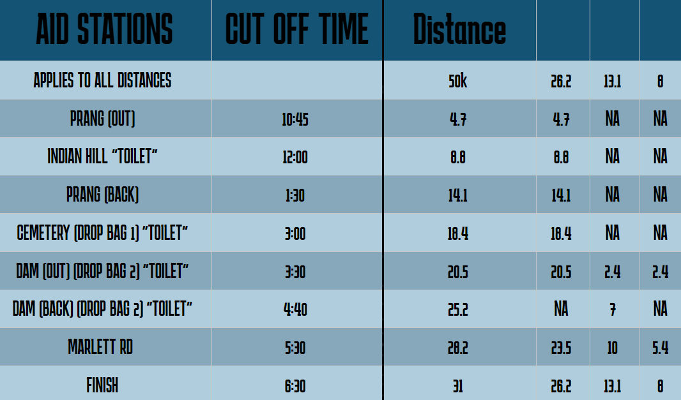
AID STATION MENU “Expect some surprises too!”
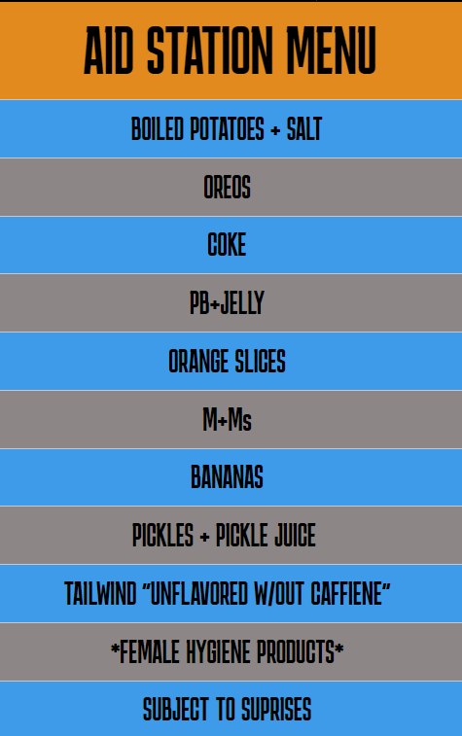

Post-Race:
- If you win an overall or age group award, it will be presented to you as you finish.
- Food and drinks are included in your fee; You will get a meal ticket when you check in. Swing by the food tent when you finish. We are serving chicken noodle soup, vegetable soup and a mashed potato bar!
- There will be a campfire or two to sit and savor your soup and your accomplishment! Finisher medals are a custom-made option and will be mailed later if you order one. The finisher medal includes your name and finish time. You may order one at registration ($10) if you did not order with your race entry.

Happy trails, we’ll see you soon! DINO and Indiana Trail Running Association

